Sheet 3
Question 1
- T(n) = T(n−1)+5, T(1) = 1 and n > 1.
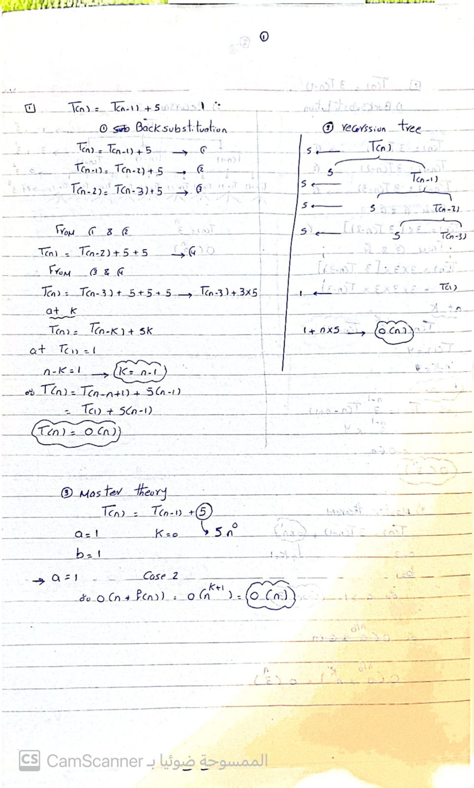

- T(n) = 3T(n−1), T(1) = 4 and n > 1
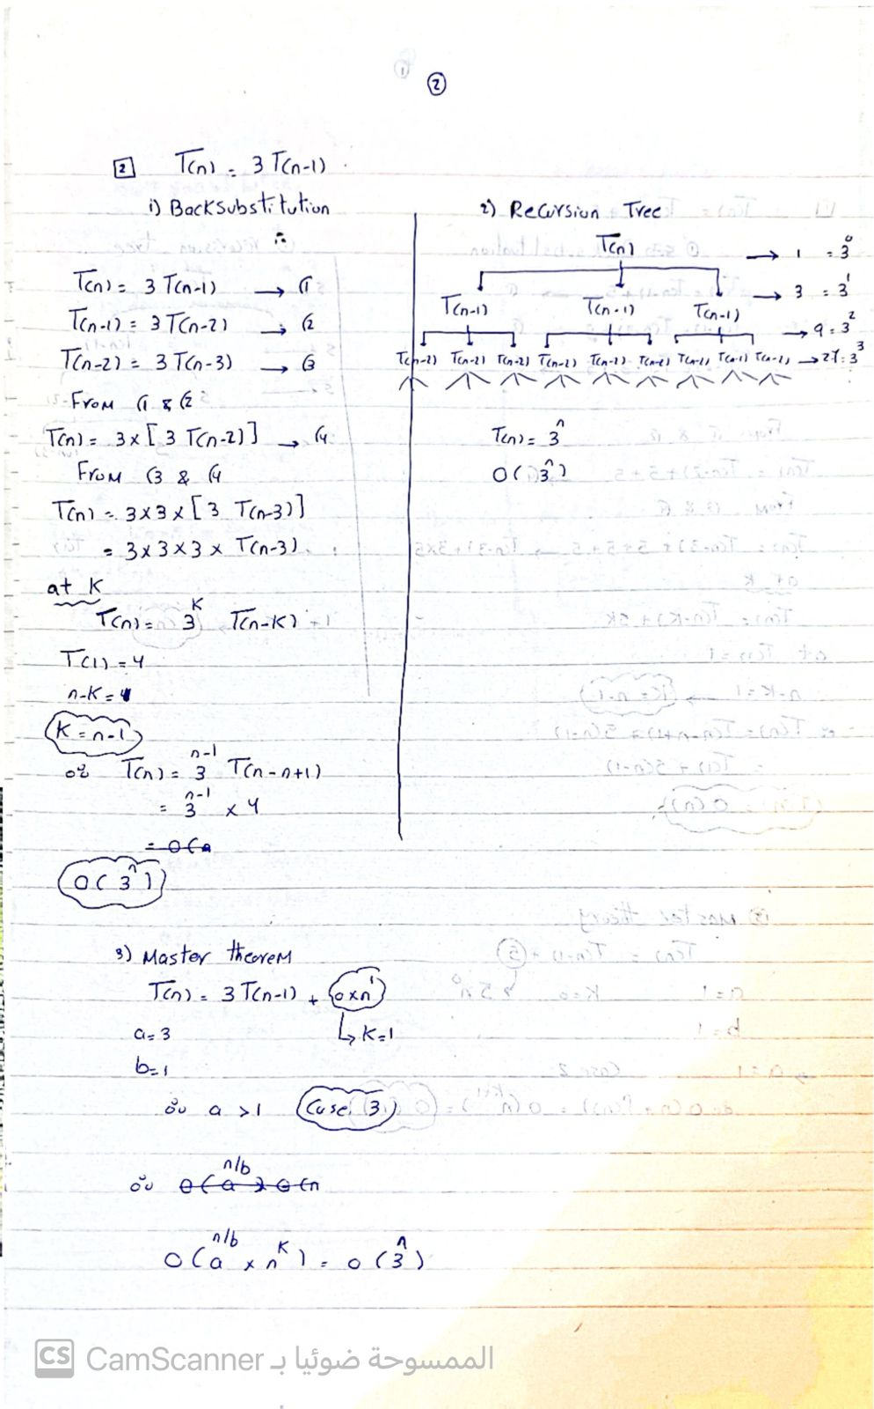

- T(n) = T(n−1)+n, T(1) = 1 and n > 0.
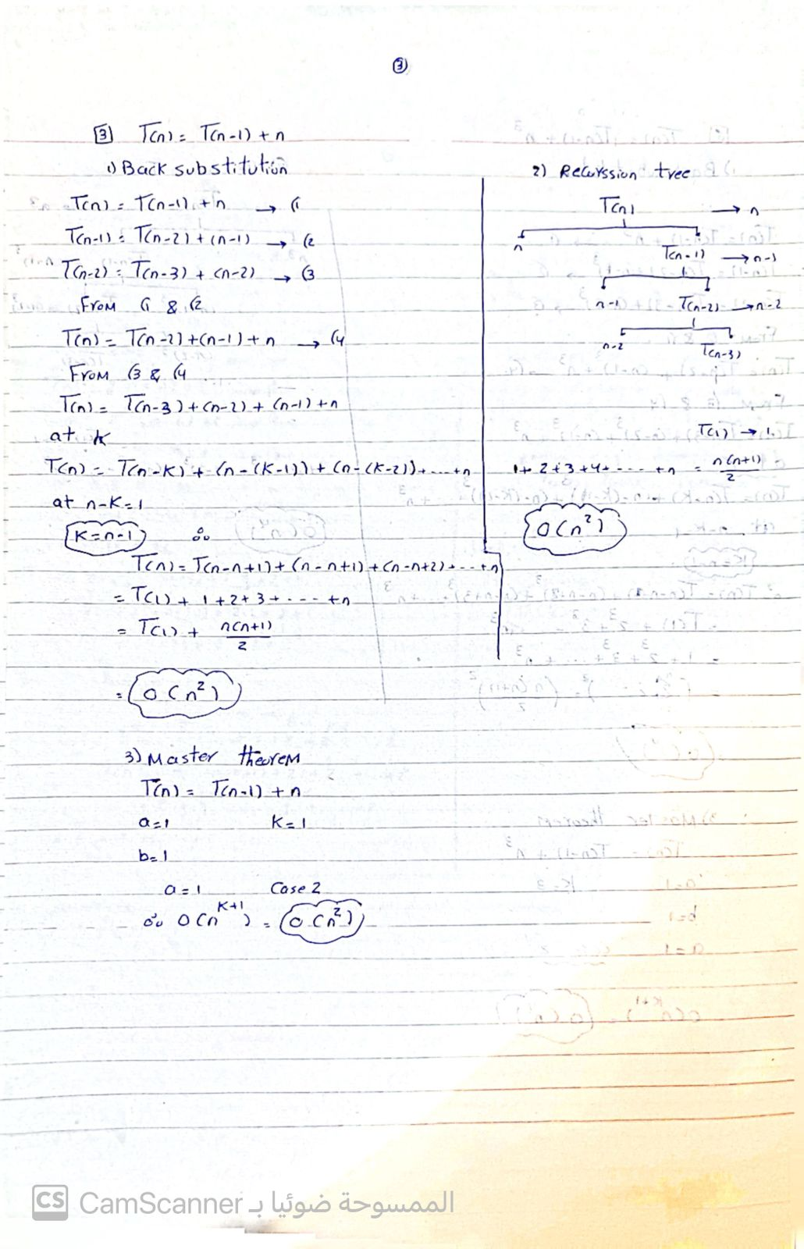
- T(n) = T(n/2)+n, T(1) = 1 and n > 1
Master theorem :
a = 1, b = 2, k = 1 case 3 O(n)
- T(n) = T(n/3)+0, T(1) = 1 and n > 1.
Master theorem :
a = 1, b = 3, k = 0 case 2 O(logn)

- T(n) = T(n−1)+n3, T(1) = 1 and n > 1
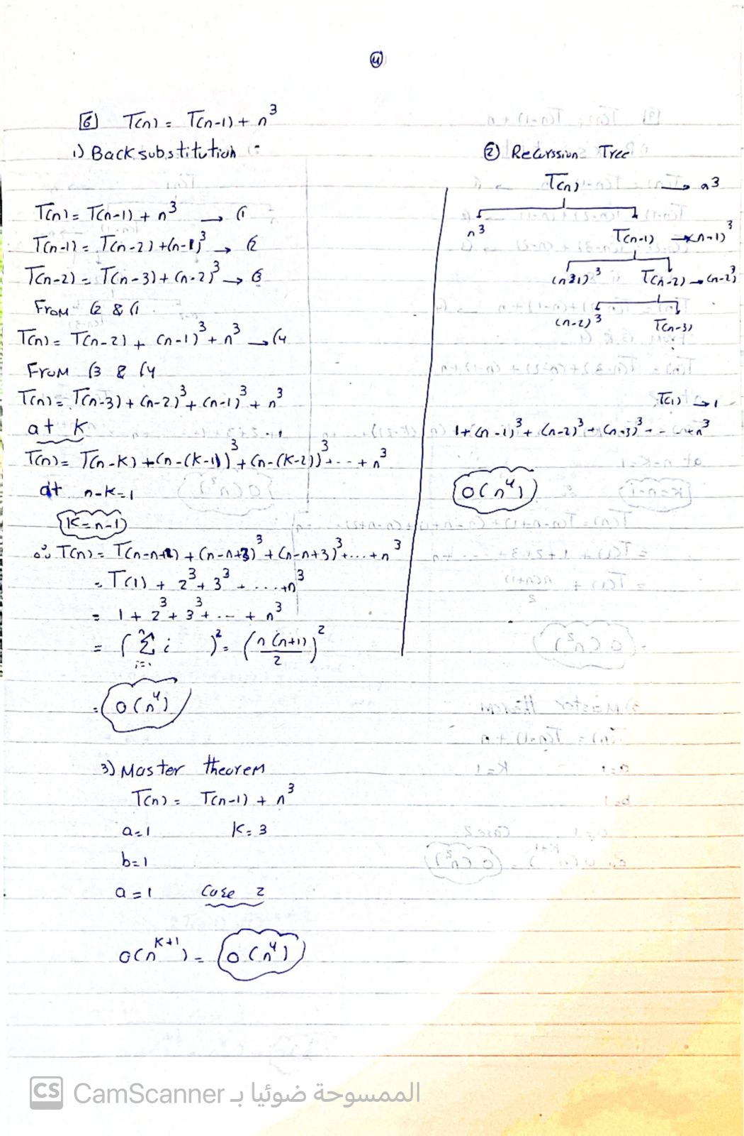
- T(n) = 2T(n/2)+n, T(1) = 1 and n > 1
Master theorem :
a = 2, b = 2, k = 1 case 2 O(nlogn)
- T(n) = 4T(n/3)+n, T(1) = 1 and n > 1
Master theorem :
a = 4, b = 3, k = 1 case 1 O(n^1.908)
- T(n) = 2T(n/2)+logn, T(1) = 1 and n > 1
Master theorem :
a = 2, b = 2 case 2 O(n)
10. T(n) = 2T(n/2)+n2, T(1) = 1 and n > 1
Master theorem :
a = 2, b = 2, k = 2 case 3 O(n^2)
11.T(n) = 2T(n/4)+√n, T(1) = 1 and n > 1
Master theorem :
a = 2, b = 4, k = 1/2 case 2 O(sqrt(n) logn)

Question 2
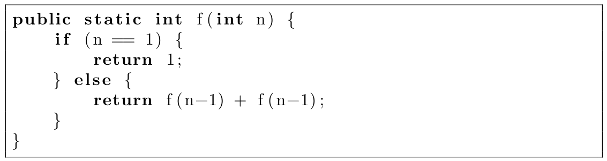
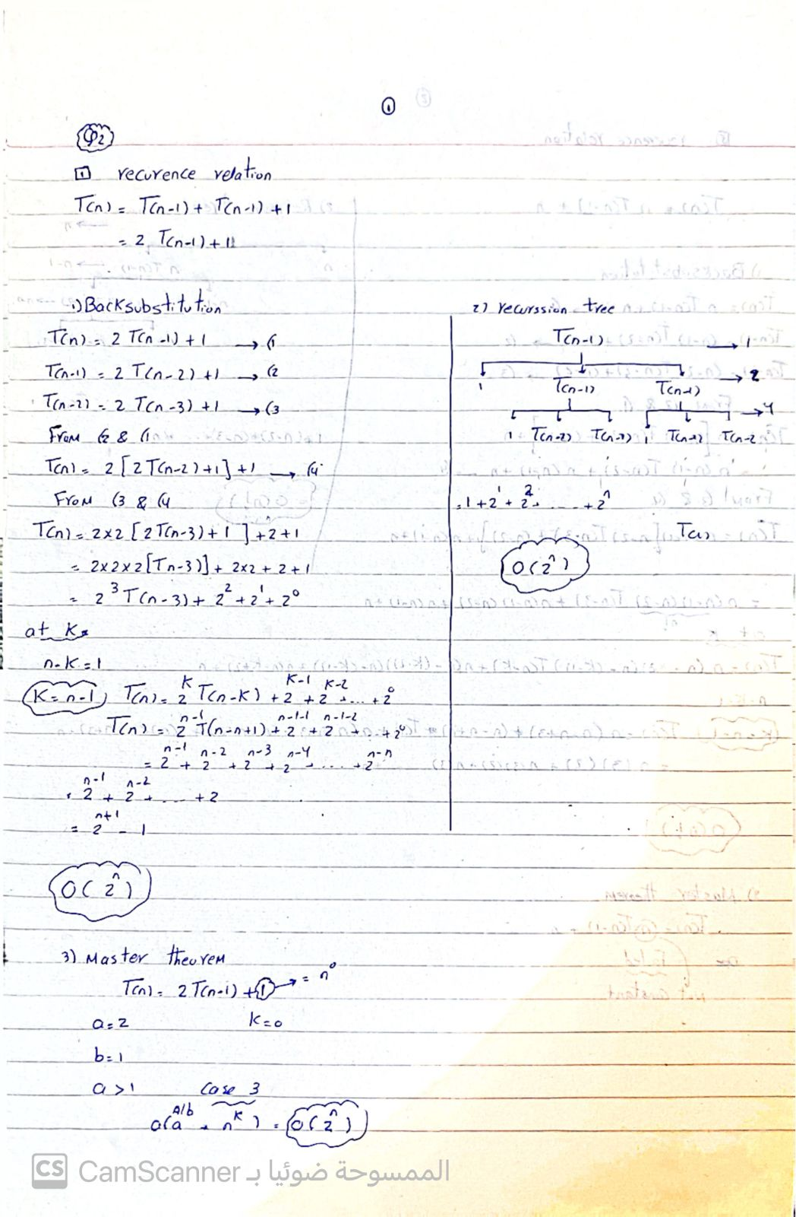
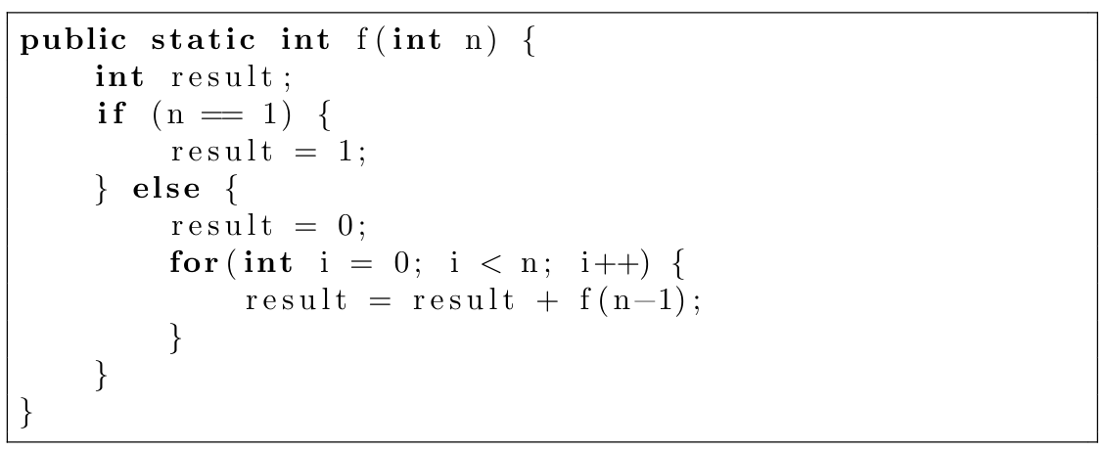
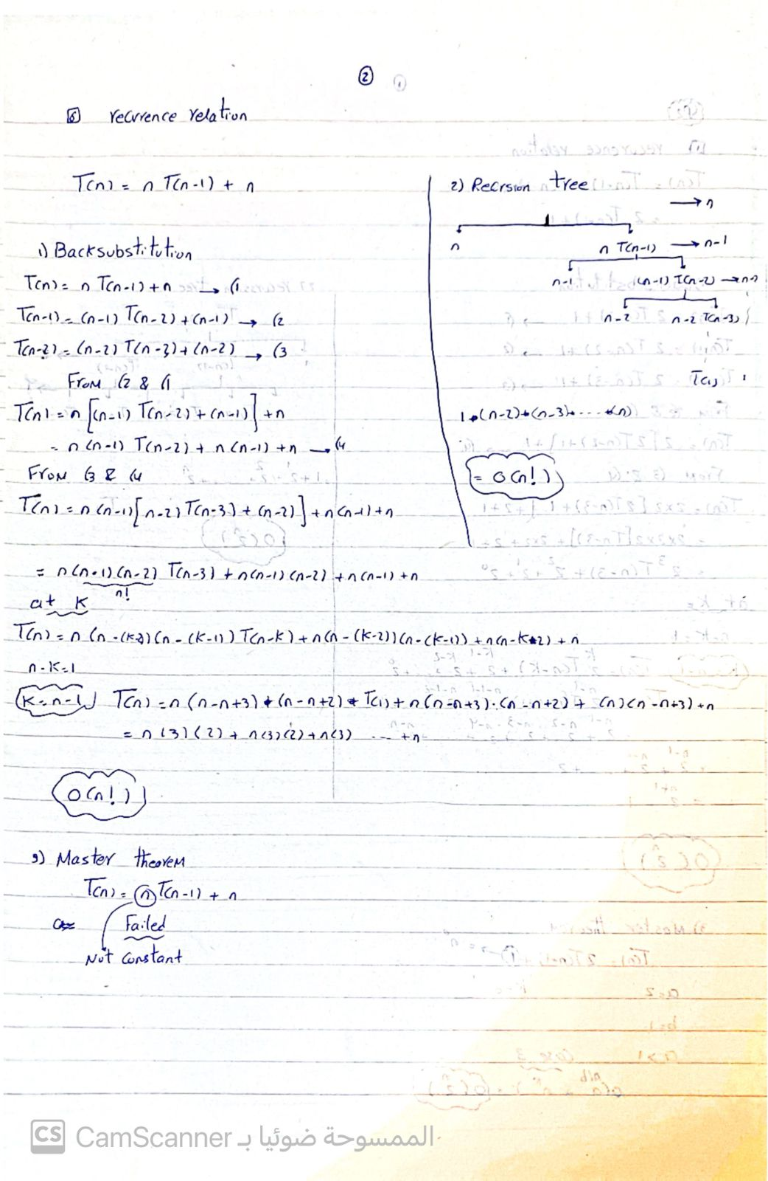
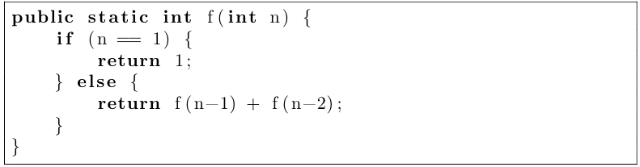
Fibonacci -> O(2^n)
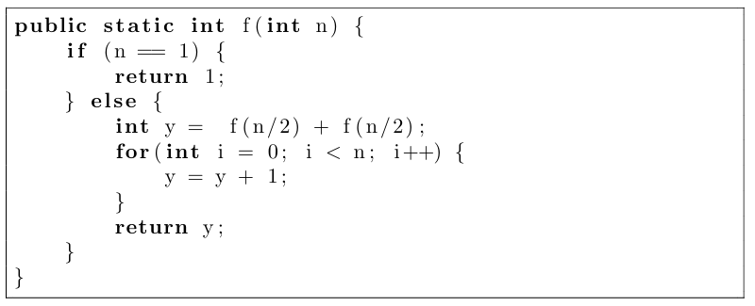
T(n) = 2 T(n/2) + n
Master Theorem :
a = 2, b = 2, f(n) = n ^ log2(2) = n, so k = 1
case 2 -> O(nlogn)

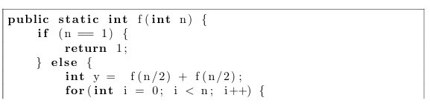
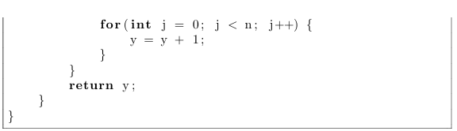
T(n) = 2 T(n/2) + n^2
Master Theorem :
a = 2, b = 2, k = 2
case 3 -> O(n^2)

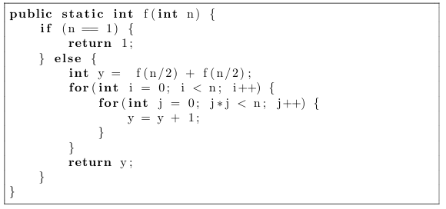
T(n) = 2 T(n/2) + n^(3/2)
Master theorem :
a = 2, b = 2, k = 3/2
case 3 -> O(n^(3/2))

